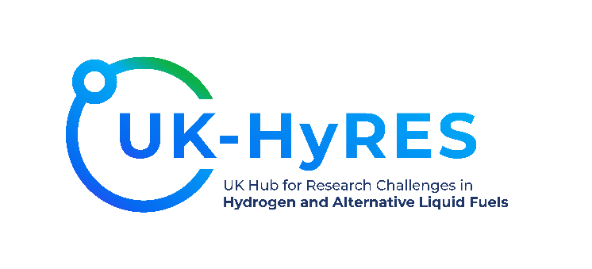

**UK-HyRES Branding**

PLEASE REMEMBER –Not just hydrogen (mostly), we also look at alternative liquid fuels (see Scriberia output under Colours 2)

**Standard Main Logo V1** ---- **Use this logo in most cases. Nb. We are happy for the border around the logo to be cropped to the minimum size indicated in red below.** Medium resolution (12400 x 5641) .png > [UK-HyRES_Final_02-01.png](https://computingservices.sharepoint.com/:i:/r/sites/HydrogenHub/Shared%20Documents/General/Graphics%20%26%20Branding/UK-HyRES_Final_02-01.png?csf=1&web=1&e=pRZ9Ws)

1. High resolution vectorised .ai (best for large graphics / banners etc.) > [UK-HyRES_Logo_Final_02 2 (2).ai](https://computingservices.sharepoint.com/:u:/r/sites/HydrogenHub/Shared%20Documents/General/Graphics%20%26%20Branding/UK-HyRES_Logo_Final_02%202%20(2).ai?csf=1&web=1&e=btPfiZ)

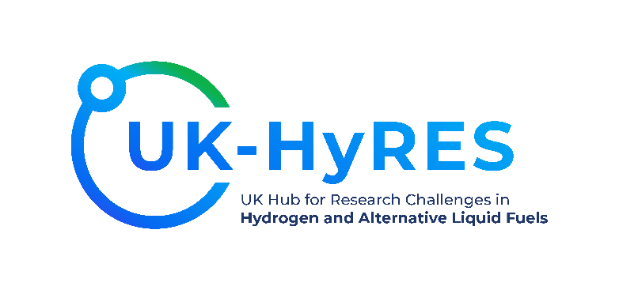

When in conjunction with our sibling hub HI-ACT, please refer to us as: The EPSRC hydrogen hubs, UK-HyRES and HI-ACT. Our logo should be displayed such that the bottom text aligns as indicated by the red line in overlay.



**Required to use the EPSRC logo somewhere**

[UKRI_EPSR_Council-Logo_Horiz-RGB.png](https://computingservices.sharepoint.com/:i:/r/sites/HydrogenHub/Shared%20Documents/General/Graphics%20%26%20Branding/UKRI_EPSR_Council-Logo_Horiz-RGB.png?csf=1&web=1&e=AuMfIt) (Horizontal) [ukri-epsrc-square-logo.png](https://computingservices.sharepoint.com/:i:/r/sites/HydrogenHub/Shared%20Documents/General/Graphics%20%26%20Branding/ukri-epsrc-square-logo.png?csf=1&web=1&e=NhLgap) (Square)



or

**Font**

https://fonts.google.com/specimen/Montserrat

Montserrat

Colours 1



Colours 2

